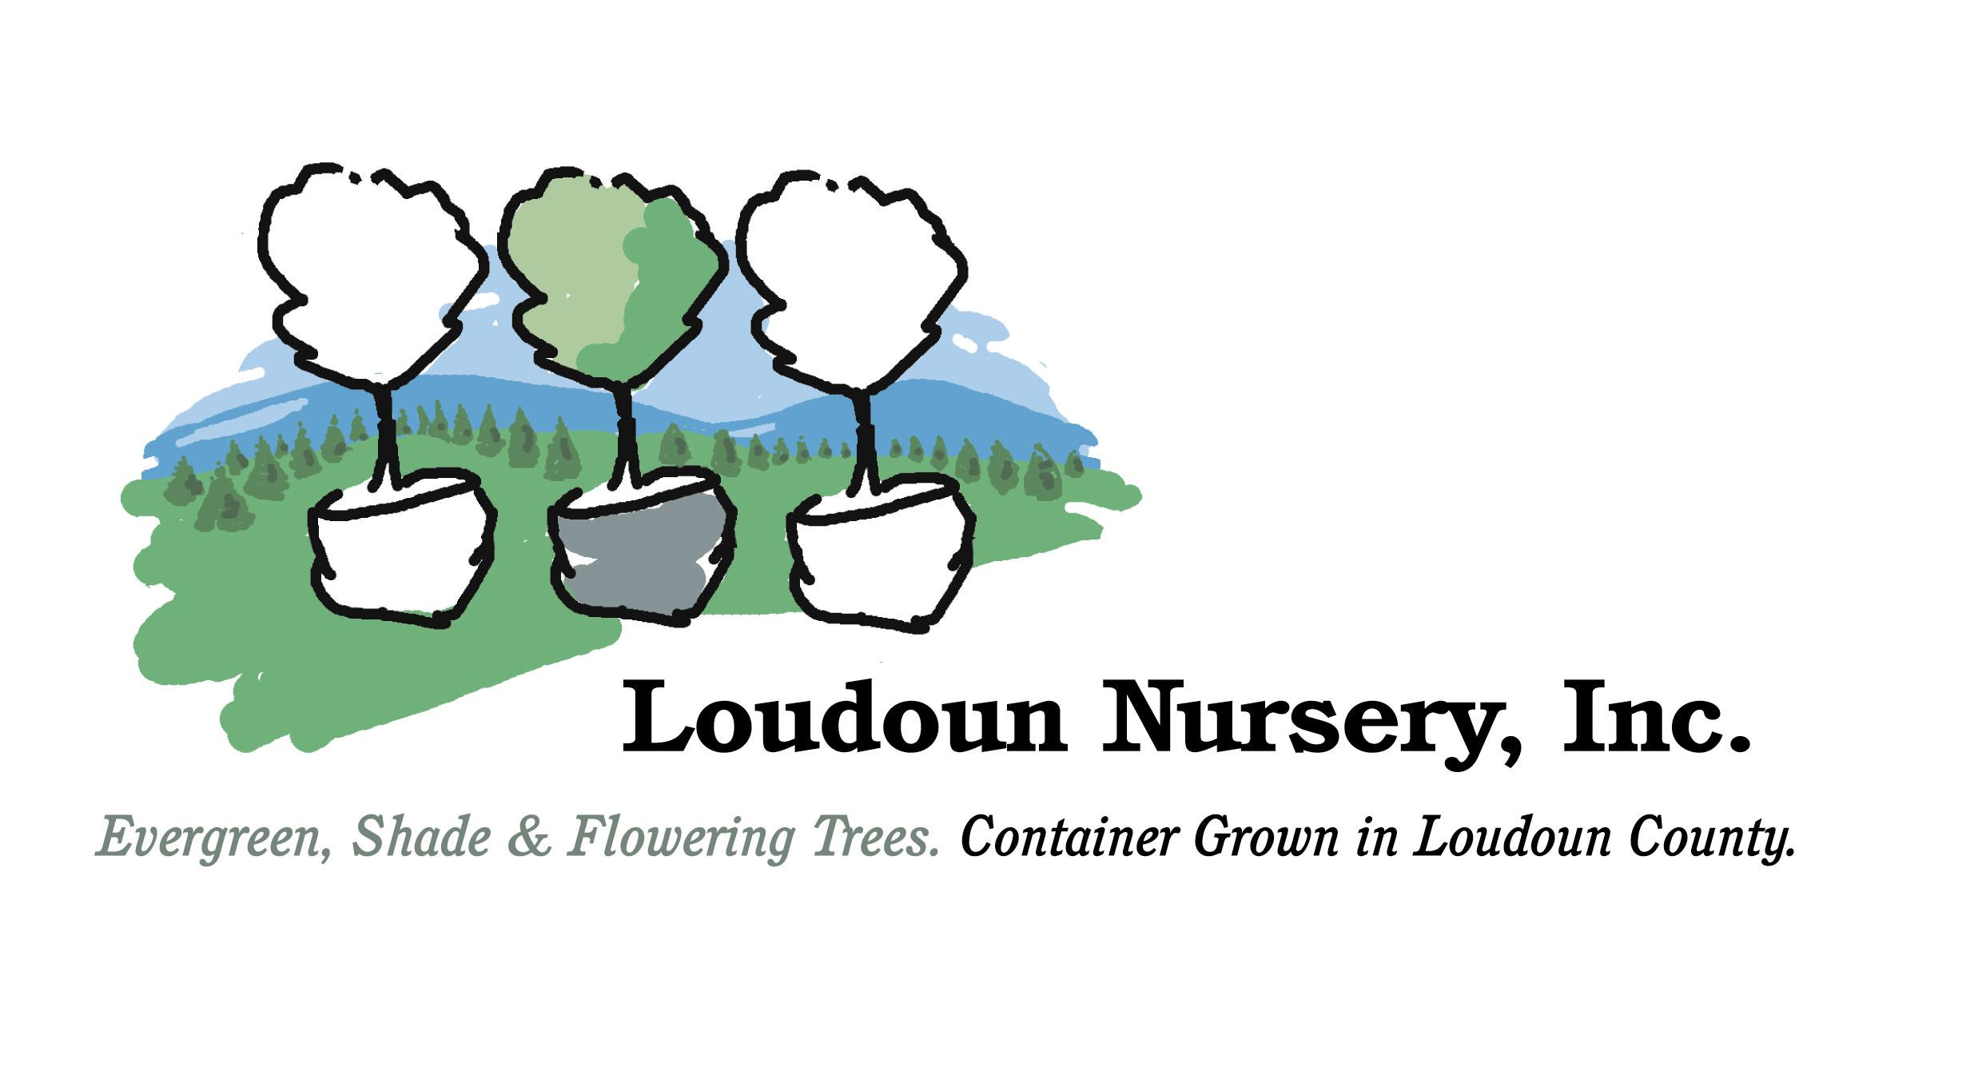

Gift Certificate

For

_____________________________

In the amount of

________________________

Please select your tree(s) from Loudoun Nursery, Inc

You may visit the nursery by appointment at any time

